Order Of Service

Singing: Psalm 98—CW page 103

Reading: Psalm 144

Opening Hymn: TLH 62

Reading: I Peter 3:1-12

Request Hymn: CW Supplement 707

Reading: Luke 22:1-6

Sermon Hymn: TLH 87

Sermon Text: Song Of Solomon 2:9

Behind Our Wall

Prayer

The Apostles’ Creed, TLH page 12

Holy Communion

The Lord's Prayer

The Blessing

Closing Hymn: TLH 66

* * * * * * * * * * *

Bible Study: Lambs: II Timothy 3:14; You Must Continue
Sheep: Proverbs 7:10-15; Your Choice
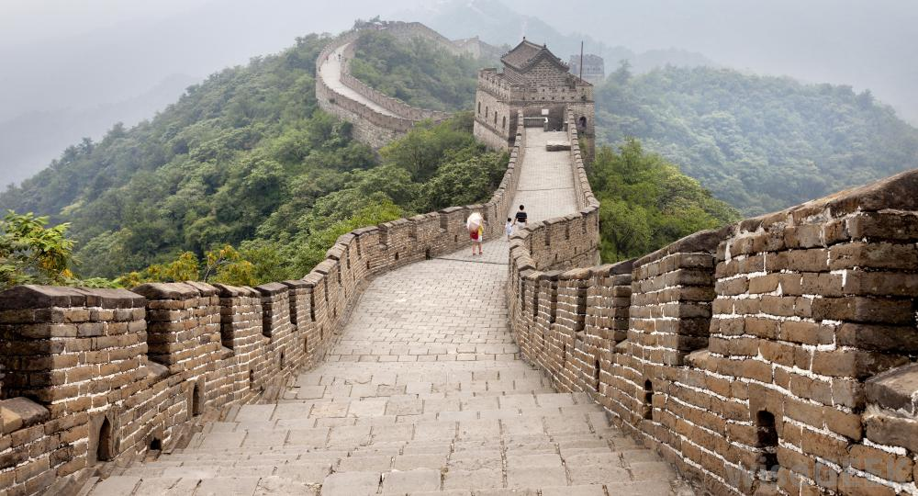

Behind Our Wall

Water
Of
Life

27 December 2015

W A T E R O F L I F E

Independent Christian Church—Conservative Lutheran Doctrine

Worship Service: 9:30 a.m. Bible Study: 10:45 a.m.

Larry Cooper, Pastor E-Mail address:
111 N. Ridge Road lcooper@wateroflife.cc
Coon Valley, WI 54623 Web Site:
Phone: (608) 452-2105 www.wateroflife.cc

* * * * * * * * * * * * * * * * * * * * * * * * * * *

Sermon Text: Song Of Solomon 2:9

Behind Our Wall

* * * * * * * * * * * * * * * * * * * * * * * * * * *

Song of Solomon 2:9 My beloved is like a roe or a young hart: behold, he standeth behind our wall, he looketh forth at the windows, shewing himself through the lattice.

Walls are erected mainly to keep people out. Sometimes they work. Other times they don’t.

The Great Wall of China was erected to protect the Chinese states and empires against the raids and invasions of the various nomadic groups of the Eurasian Steppe. The wall was built over long periods of time and covered many miles. One archaeological survey found that the entire wall with all of its branches measure out to be 13,171 miles.

It must have worked rather well, I guess. At least for a while.

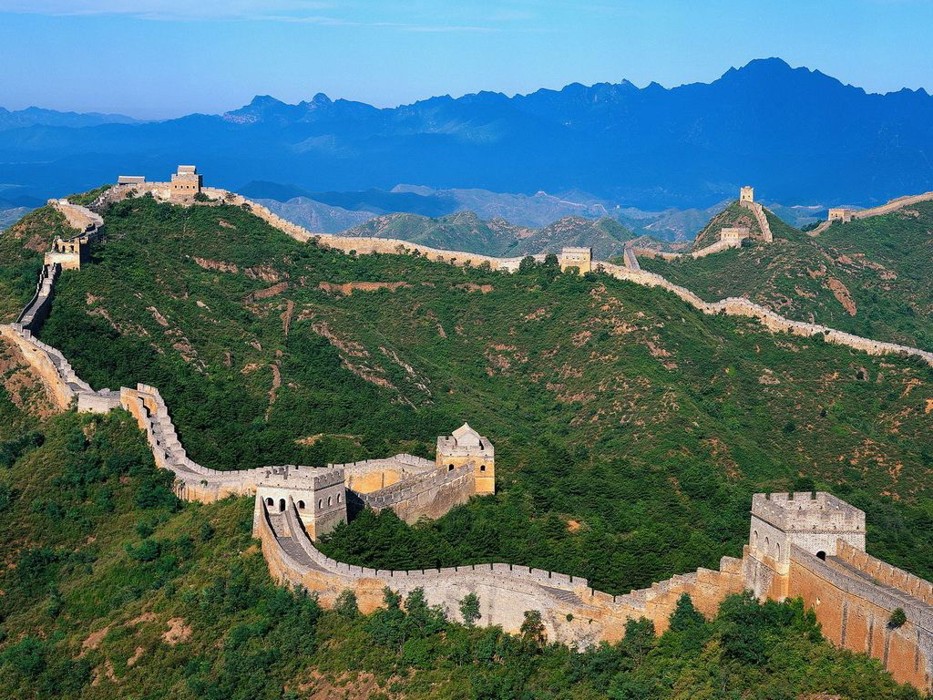

The people of the city of Jericho built a wall around their city, too. Jericho was one of those cities whose walls, according to eye witnesses, reached up to heaven.

That wall worked rather well, too. Until a group of people came blowing trumpets and shouting. And you know the rest of the story.

Here in Song of Solomon 2:9 the Bride mentions a wall also. She calls it “our wall.” Both the Bridegroom and the Bride have many enemies. And they are powerful.

But this wall is unlike any wall built with human hands. Speaking to the enemy, the Bridegroom describes it this way—“Between us and you there is a great gulf fixed.” And the enemy can’t cross it!

